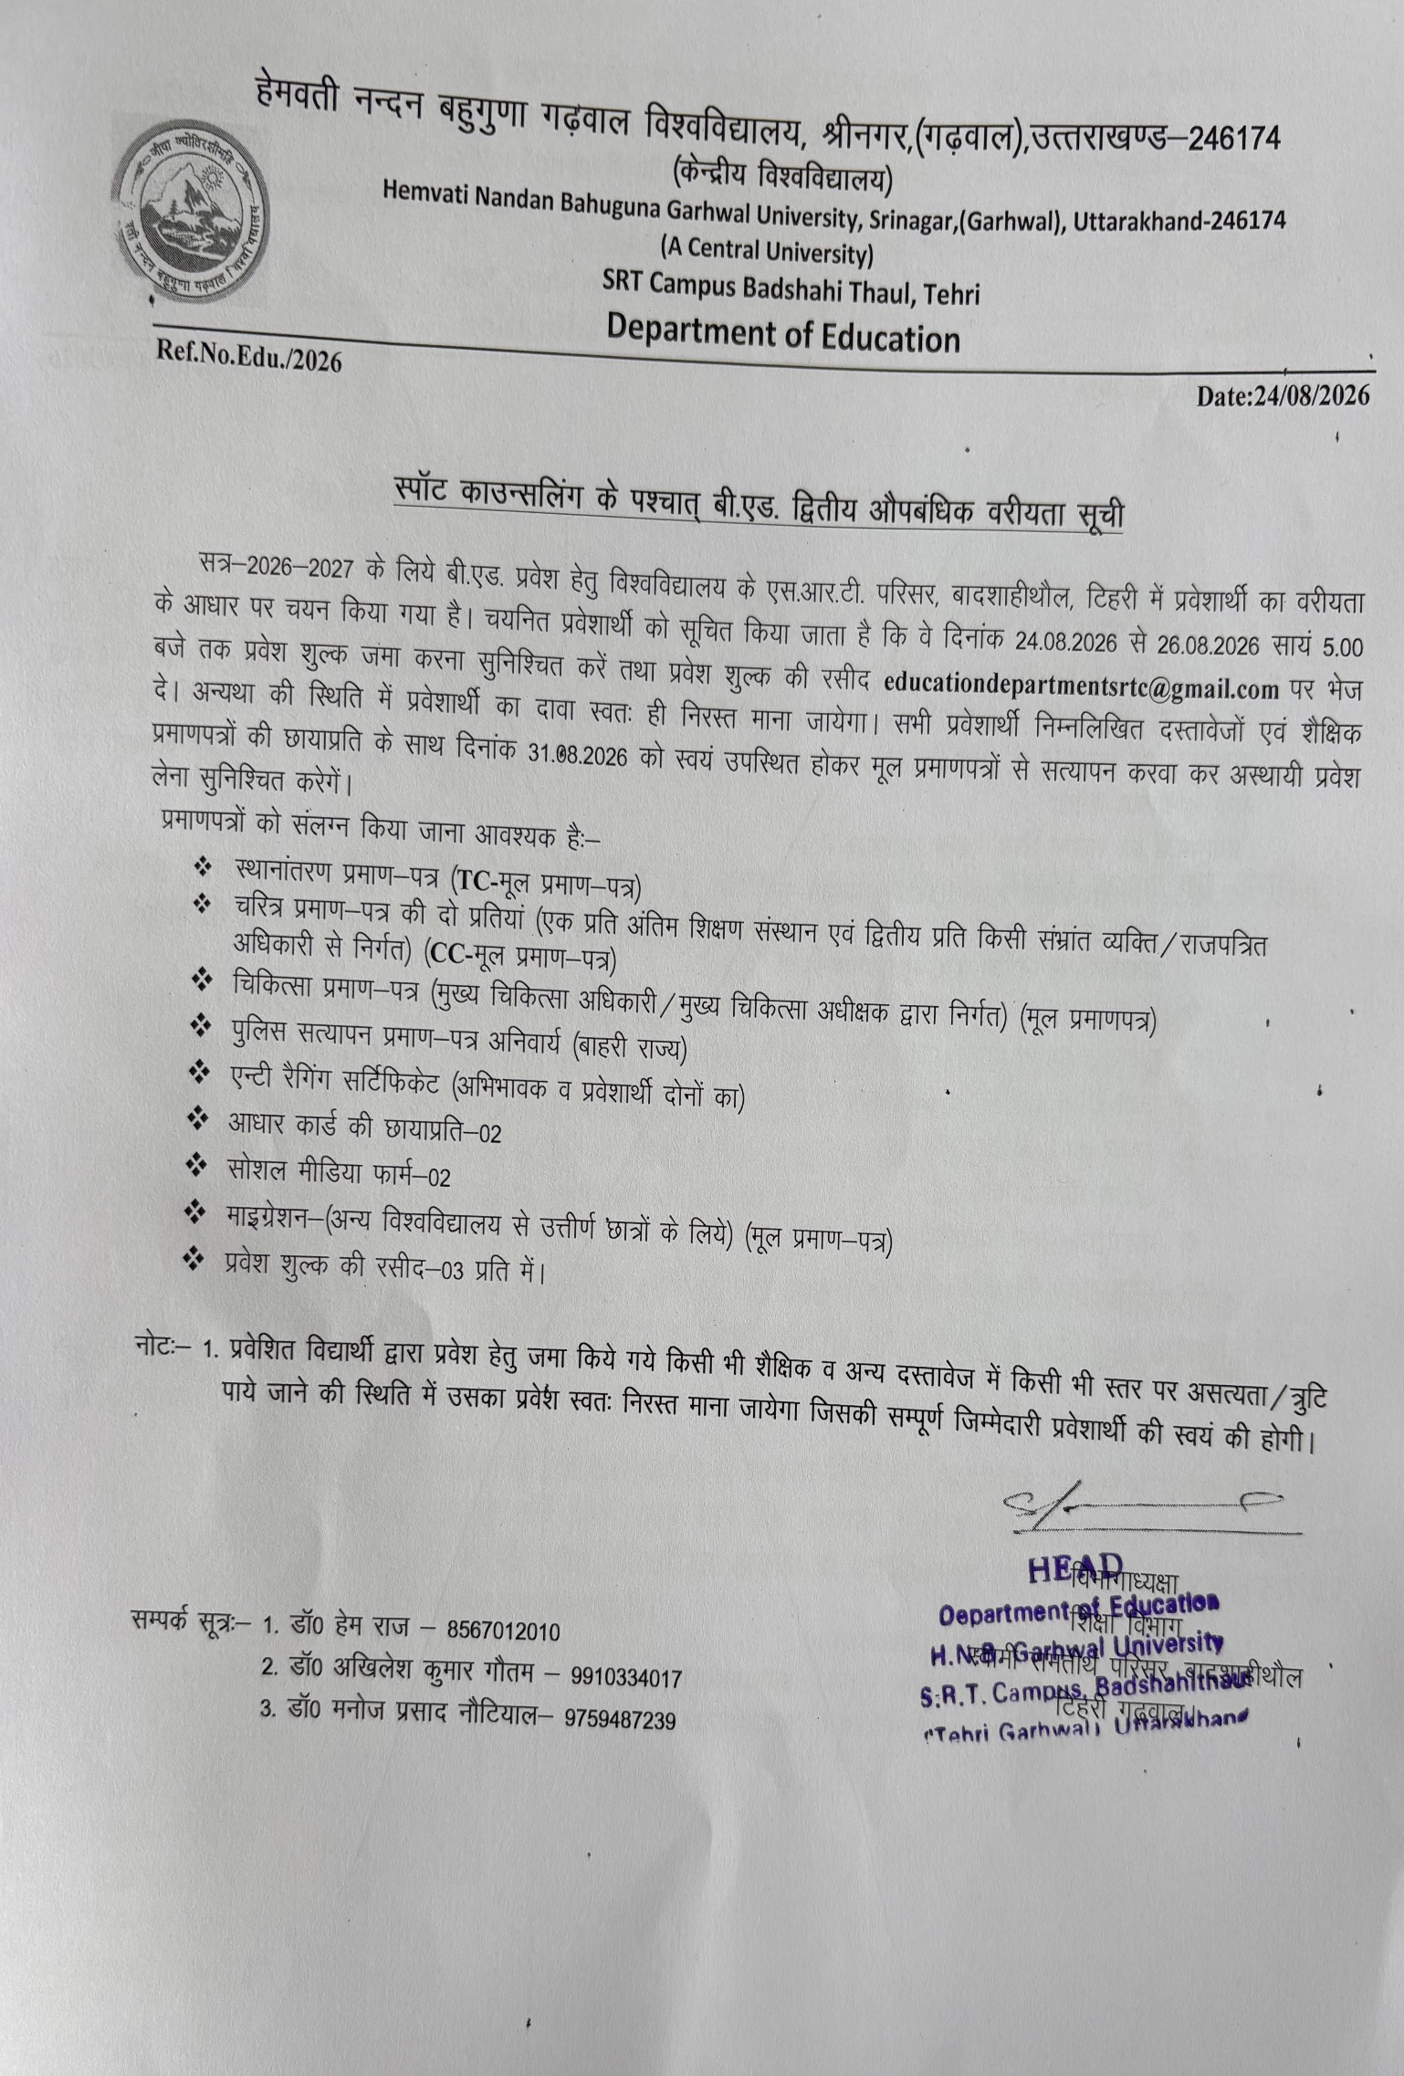

Second Merit List of B.Ed. 1st Semester (Arts/Commerce/Science) for the Session 2026-27

SCIENCE GROUP
Science Unreserved (UR)
S.No. | Form Number | Name of the Applicant | Name of Father | Gender | Category | Total score
1 | HNBGUE260049667 | Vishal Thapliyal | Vinod Prasad Thapliyal | Male | General / Open Category / Unreserved | 147
2 | Hnbgue260049326 | Anuj Singh Pundir | Raimat Singh Pundir | Male | General / Open Category / Unreserved | 145
Science OBC
1 | Hnbgue260055868 | Sachin Chauhan | Nihal Singh | Male | OBC Non Creamy | 122
Science SC
1 | HNBGUE260054274 | Harish Chandra | Mohan Lal | Male | SC | 120
2 | HNBGUE260017132 | Saurabh Kumar | Prakash Lal | Male | SC | 118
3 | HNBGUE260052315 | Sujal Nath | Gorakh Nath | Male | SC | 117
Science SC Girls (30%)
1 | HNBGUE260052358 | Sama Bharti | Mohan Lal | Female | SC | 101
Science EWS
1 | HNBGUE260018583 | Ayushi Negi | Mahabeer Negi | Female | EWS | 72

ARTS/COMMERCE

Arts/Commerce Unreserved (UR)
S.No | Form Number | Name of the Applicant | Name of Father | Gender | Category | Total score
1 | HNBGUE260057100 | Rohit Sundly | Kiri Ram Sundly | Male | General / Open Category / Unreserved | 133
2 | HNBGUE260019093 | Aman Jha | Amit Kumar Jha | Male | General / Open Category / Unreserved | 130
3 | HNBGUE260050883 | Shivani Negi | Laxman Singh Negi | Female | General / Open Category / Unreserved | 128
Arts/Commerce OBC
1 | HNBGUE260052829 | Manveer Singh | Shishpal Singh | Male | OBC Non Creamy | 123
Arts/Commerce OBC Girls (30%)
1 | HNBGUE260056642 | Preeti Chamoli | Premlal Chamoli | Female | OBC Non Creamy | 105
2 | HNBGUE260018562 | Ipsita Naik | Santosh Kumar Naik | Female | OBC Non Creamy | 102
Arts/Commerce SC
1 | HNBGUE260018515 | Bhuvnesh Kumar | Magnu Kumar | Male | SC | 106
Arts/Commerce ST
1 | HNBGUE260052035 | Suman Chauhan | Sultan Singh | Female | ST | 91

